FATIMA JINNAH WOMEN UNIVERSITY



“Compiler Construction”
BCS-6A

Submitted by:
Sidra Liaqat(2023-BCS-083)
Sidra Tul Muntaha (2023-BCS-084)
Submitted to: Dr Bushra Sikander.
PROJECT MODULE 02

Department of Computer Science

Question: Convert the following "lexer.cpp" and "test.txt" code as per your own grammar and project description.
Code the lexical phase of your compiler.

CODE:
// S++ Lexer
// Complete rewrite with standard C++ headers

#include <iostream>
#include <fstream>
#include <cctype>
#include <cstring>
#include <cstdlib>
using namespace std;

// Tokens of the S++ language
enum Tokens
{
// program starting token
smainTok,

// i/o statements
sinTok, soutTok,

// relational operators
sltTok, sgtTok, sseeTok, sleTok, sgeTok, sneTok,

// arithmetic operators
splusTok, sminTok, smulTok, sdivTok, smodTok, spowTok,

// assignment operator
seqTok,

// data types
scharTok, sintTok, sfloatTok, sdoubleTok, sstringTok,

// punctuations
commaTok, seosTok, startParenTok, endParenTok,
startBraceTok, endBraceTok, startSquareTok, endSquareTok,

// logical operators
sandTok, sorTok, snotTok,

// bitwise operators
sbaTok, sboTok, sbnTok, sbrsTok, sblsTok,

// Identifier (starts with @)
idenTok,

// constant declaration
sconstTok,

// conditional statements
sifTok, selifTok, selseTok, sswitchTok, scaseTok, sdefaultTok,

// loops
sforTok, swhileTok, sdoTok,

// jump statements
sjumTok,

// constants
charConstTok, intConstTok, realConstTok, stringConstTok,

// end of file token
eofTok,

// illegal character
illegalTok
};

// Structure for reserved words
struct resWords
{
char name[12];
Tokens tok;
};

// Table for reserved words in S++ (all start with 's')
resWords RWtable[] =
{
{"sbreak", sjumTok},
{"scase", scaseTok},
{"schar", scharTok},
{"sconst", sconstTok},
{"scontinue", sjumTok},
{"sdefault", sdefaultTok},
{"sdo", sdoTok},
{"sdouble", sdoubleTok},
{"selif", selifTok},
{"selse", selseTok},
{"sfloat", sfloatTok},
{"sfor", sforTok},
{"sif", sifTok},
{"sint", sintTok},
{"smain", smainTok},
{"sreturn", sjumTok},
{"sin", sinTok},
{"sout", soutTok},
{"sstring", sstringTok},
{"sswitch", sswitchTok},
{"swhile", swhileTok}
};

// Global variables
ifstream infile;
char ch = ' ';
Tokens token;
int lineNo = 1, tempLineNo;
const int ID_LENGTH = 16;
char idenValue[ID_LENGTH + 1];
const int NSRW = 21; // number of reserved words
const int LSRW = 10;
const int STR_LENGTH = 200;
char stringValue[STR_LENGTH + 1];
char chValue;
int intValue;
float floatValue;
int stringLen = 0;
char illegalLexeme;

// Global functions
void nextCh();
void nextToken();
void evaluateNumber();
void evaluateChar();
void evaluateString();
void isRSW(char[]);
void printTokens(Tokens);

// Main program
int main()
{
char sourceFile[100];
cout << "Enter path of the source text program: ";
cin >> sourceFile;

infile.open(sourceFile);
if (!infile)
{
while (!infile)
{
cout << "Entered path does not exist, Please re-enter: ";
cin >> sourceFile;
infile.open(sourceFile);
}
}

cout << "\n\n List of Tokens for S++ Language" << endl << endl;
cout << "Lexemes Tokens" << endl << endl;

while (ch != '\0')
{
nextToken();
printTokens(token);
}

infile.close();
cout << "\nPress Enter to exit...";
cin.ignore();
cin.get();

return 0;
}

void nextCh()
{
infile.get(ch);
if (infile.eof())
ch = '\0';
else if (ch == '\n')
lineNo++;
}

// Definition of nextToken() for S++
void nextToken()
{
while (isspace(ch)) // skip spaces, tabs, newlines
nextCh();

// Single line comment $$
if (ch == '$')
{
nextCh();
if (ch == '$')
{
// Single line comment - skip until end of line
while (ch != '\n' && ch != '\0')
nextCh();
nextToken();
return;
}
else if (ch == '*')
{
// Multi-line comment $* ... *$
int commentStartLine = lineNo;
nextCh();
char prevCh = ' ';
while (ch != '\0')
{
if (prevCh == '*' && ch == '$')
{
nextCh();
break;
}
prevCh = ch;
nextCh();
}
if (ch == '\0')
{
cout << "\nUnexpected end of file in comment started on line "
<< commentStartLine << endl;
}
nextToken();
return;
}
else
{
// $ alone is illegal
token = illegalTok;
illegalLexeme = '$';
return;
}
}

// Identifier: must start with @
else if (ch == '@')
{
nextCh();
if (isalpha(ch) || isdigit(ch))
{
int i = 0;
idenValue[i] = '@';
i++;
idenValue[i] = ch;
idenValue[i + 1] = '\0';
nextCh();

while (isalpha(ch) || isdigit(ch))
{
i++;
idenValue[i] = ch;
idenValue[i + 1] = '\0';
nextCh();
}
token = idenTok;
}
else
{
// @ followed by invalid character
token = illegalTok;
illegalLexeme = '@';
}
}

// Check for keywords (start with s)
else if (ch == 's')
{
char tempStr[ID_LENGTH + 1];
int i = 0;
tempStr[i] = ch;
i++;
nextCh();

while (isalpha(ch))
{
tempStr[i] = ch;
i++;
nextCh();
}
tempStr[i] = '\0';

// Check if it's a reserved word
int found = 0;
for (int j = 0; j < NSRW; j++)
{
if (strcmp(tempStr, RWtable[j].name) == 0)
{
token = RWtable[j].tok;
strcpy(idenValue, tempStr);
found = 1;
break;
}
}
if (!found)
{
// Not a keyword - but S++ identifiers must start with @
token = illegalTok;
illegalLexeme = tempStr[0];
}
}

// Numbers
else if (isdigit(ch))
{
token = intConstTok;
evaluateNumber();
}

else
switch (ch)
{
// End of statement - full stop (.)
case '.':
token = seosTok;
nextCh();
break;

case ',':
token = commaTok;
nextCh();
break;

case '\'':
evaluateChar();
break;

case '\"':
token = stringConstTok;
nextCh();
evaluateString();
nextCh();
break;

case '(':
token = startParenTok;
nextCh();
break;

case ')':
token = endParenTok;
nextCh();
break;

case '{':
token = startBraceTok;
nextCh();
break;

case '}':
token = endBraceTok;
nextCh();
break;

case '[':
token = startSquareTok;
nextCh();
break;

case ']':
token = endSquareTok;
nextCh();
break;

// Logical AND &&
case '&':
nextCh();
if (ch == '&')
{
token = sandTok;
nextCh();
}
else
{
token = sbaTok;
}
break;

// Logical OR ||
case '|':
nextCh();
if (ch == '|')
{
token = sorTok;
nextCh();
}
else
{
token = sboTok;
}
break;

case '!':
token = snotTok;
nextCh();
break;

case '~':
token = sbnTok;
nextCh();
break;

// Assignment and equality
case '=':
token = seqTok;
nextCh();
if (ch == '=')
{
token = sseeTok;
nextCh();
}
break;

// Relational operators
case '<':
token = sltTok;
nextCh();
if (ch == '=')
{
token = sleTok;
nextCh();
}
else if (ch == '<')
{
token = sblsTok;
nextCh();
}
break;

case '>':
token = sgtTok;
nextCh();
if (ch == '=')
{
token = sgeTok;
nextCh();
}
else if (ch == '>')
{
token = sbrsTok;
nextCh();
}
break;

case '*':
token = smulTok;
nextCh();
break;

case '/':
token = sdivTok;
nextCh();
break;

case '+':
token = splusTok;
nextCh();
break;

case '-':
token = sminTok;
nextCh();
break;

case '%':
token = smodTok;
nextCh();
break;

case '^':
token = spowTok;
nextCh();
break;

case '\0':
token = eofTok;
break;

default:
illegalLexeme = ch;
token = illegalTok;
nextCh();
}
}

// Definition of evaluateNumber()
void evaluateNumber()
{
intValue = ch - 48;
nextCh();
while (isdigit(ch))
{
intValue = intValue * 10 + (ch - 48);
nextCh();
}
if (ch == '.')
{
token = realConstTok;
floatValue = (float)intValue;
nextCh();
for (int i = 10; isdigit(ch); i *= 10)
{
floatValue = floatValue + (float)(ch - 48) / i;
nextCh();
}
}
}

// Definition of evaluateChar()
void evaluateChar()
{
tempLineNo = lineNo;
nextCh();
chValue = ch;
nextCh();
if (ch != '\'')
{
cout << "\nUnterminated character constant on line " << tempLineNo << "\n\n";
while (ch != '\n')
nextCh();
nextToken();
}
else
{
token = charConstTok;
nextCh();
}
}

// Definition of evaluateString()
void evaluateString()
{
tempLineNo = lineNo;
int i = 0;
for (i = 0; i < STR_LENGTH && ch != '\"' && ch != '\n'; i++)
{
stringValue[i] = ch;
nextCh();
}
stringValue[i] = '\0';
stringLen = i + 1;
if (ch == '\n')
cout << "\n Unterminated string constant starting on line "
<< tempLineNo << "\n\n";
}

// Definition of isRSW(char[])
void isRSW(char item[LSRW + 1])
{
int found = 0;
int first = 0;
int loc;
int last = NSRW - 1;
while (first <= last && !found)
{
loc = (first + last) / 2;
if (strcmp(item, RWtable[loc].name) < 0)
last = loc - 1;
else if (strcmp(item, RWtable[loc].name) > 0)
first = loc + 1;
else
{
token = RWtable[loc].tok;
found = 1;
}
}
}

// Definition of printTokens()
void printTokens(Tokens t)
{
switch (t)
{
case smainTok:
cout << idenValue << " smainTok" << endl;
break;
case sinTok:
cout << idenValue << " sinTok" << endl;
break;
case soutTok:
cout << idenValue << " soutTok" << endl;
break;
case sltTok:
cout << "<" << " sltTok" << endl;
break;
case sgtTok:
cout << ">" << " sgtTok" << endl;
break;
case sseeTok:
cout << "==" << " sseeTok" << endl;
break;
case sleTok:
cout << "<=" << " sleTok" << endl;
break;
case sgeTok:
cout << ">=" << " sgeTok" << endl;
break;
case sneTok:
cout << "!=" << " sneTok" << endl;
break;
case splusTok:
cout << "+" << " splusTok" << endl;
break;
case sminTok:
cout << "-" << " sminTok" << endl;
break;
case smulTok:
cout << "*" << " smulTok" << endl;
break;
case sdivTok:
cout << "/" << " sdivTok" << endl;
break;
case smodTok:
cout << "%" << " smodTok" << endl;
break;
case spowTok:
cout << "^" << " spowTok" << endl;
break;
case seqTok:
cout << "=" << " seqTok" << endl;
break;
case scharTok:
cout << idenValue << " scharTok" << endl;
break;
case sintTok:
cout << idenValue << " sintTok" << endl;
break;
case sfloatTok:
cout << idenValue << " sfloatTok" << endl;
break;
case sdoubleTok:
cout << idenValue << " sdoubleTok" << endl;
break;
case sstringTok:
cout << idenValue << " sstringTok" << endl;
break;
case commaTok:
cout << "," << " commaTok" << endl;
break;
case seosTok:
cout << "." << " seosTok" << endl;
break;
case startParenTok:
cout << "(" << " startParenTok" << endl;
break;
case endParenTok:
cout << ")" << " endParenTok" << endl;
break;
case startBraceTok:
cout << "{" << " startBraceTok" << endl;
break;
case endBraceTok:
cout << "}" << " endBraceTok" << endl;
break;
case startSquareTok:
cout << "[" << " startSquareTok" << endl;
break;
case endSquareTok:
cout << "]" << " endSquareTok" << endl;
break;
case sandTok:
cout << "&&" << " sandTok" << endl;
break;
case sorTok:
cout << "||" << " sorTok" << endl;
break;
case snotTok:
cout << "!" << " snotTok" << endl;
break;
case sbaTok:
cout << "&" << " sbaTok" << endl;
break;
case sboTok:
cout << "|" << " sboTok" << endl;
break;
case sbnTok:
cout << "~" << " sbnTok" << endl;
break;
case sbrsTok:
cout << ">>" << " sbrsTok" << endl;
break;
case sblsTok:
cout << "<<" << " sblsTok" << endl;
break;
case idenTok:
cout << idenValue << " idenTok" << endl;
break;
case sconstTok:
cout << idenValue << " sconstTok" << endl;
break;
case sifTok:
cout << idenValue << " sifTok" << endl;
break;
case selifTok:
cout << idenValue << " selifTok" << endl;
break;
case selseTok:
cout << idenValue << " selseTok" << endl;
break;
case sswitchTok:
cout << idenValue << " sswitchTok" << endl;
break;
case scaseTok:
cout << idenValue << " scaseTok" << endl;
break;
case sforTok:
cout << idenValue << " sforTok" << endl;
break;
case swhileTok:
cout << idenValue << " swhileTok" << endl;
break;
case sdoTok:
cout << idenValue << " sdoTok" << endl;
break;
case sdefaultTok:
cout << idenValue << " sdefaultTok" << endl;
break;
case sjumTok:
cout << idenValue << " sjumTok" << endl;
break;
case stringConstTok:
if (stringLen == 1)
cout << "null";
else
for (int i = 0; i < stringLen - 1; i++)
cout << stringValue[i];
cout << " stringConstTok" << endl;
break;
case charConstTok:
cout << chValue << " charConstTok" << endl;
break;
case intConstTok:
cout << intValue << " intConstTok" << endl;
break;
case realConstTok:
cout << floatValue << " realConstTok" << endl;
break;
case eofTok:
cout << "\\0" << " eofTok" << endl;
break;
case illegalTok:
cout << illegalLexeme << " illegalTok" << endl;
break;
default:
break;
}
}

OUTPUT:
Text File which contains code to be implemented by the Lexical Analyzer
text.txt
smain {
$$ Data types demonstration
sint @integerVar = 100.
sfloat @floatVar = 45.67.
sdouble @doubleVar = 123.456789.
schar @charVar = 'Z'.
sstring @stringVar = "S++ Language".

$$ Arithmetic operations
sint @add = @integerVar + 50.
sint @sub = @integerVar - 30.
sint @mul = @integerVar * 2.
sint @div = @integerVar / 5.
sint @mod = @integerVar % 7.
sint @pow = @integerVar ^ 2.

sout @add.
sout @sub.
sout @mul.
sout @div.
sout @mod.
sout @pow.

$$ Relational operations
sif (@integerVar == 100) {
sout "Value is 100".
}
selif (@integerVar > 100) {
sout "Value is greater than 100".
}
selse {
sout "Value is less than 100".
}

$$ Loop with for
sfor (@i = 1 to 10) {
sout @i.
}

$$ Bitwise operations
sint @bitAnd = @integerVar & 255.
sint @bitOr = @integerVar | 0.

$$ Nested conditions
sif (@integerVar > 0) {
sif (@integerVar < 200) {
sout "Value is between 0 and 200".
}
}

$$ Comment examples
$$ This is a single line comment

$* This is a
multi-line comment
that spans multiple lines *$
}
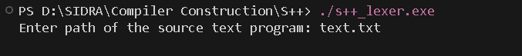
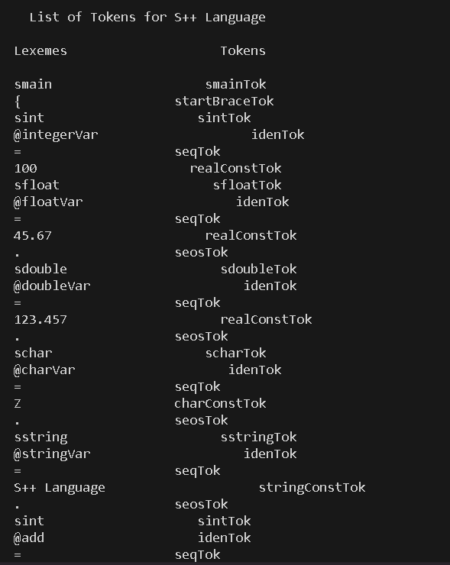
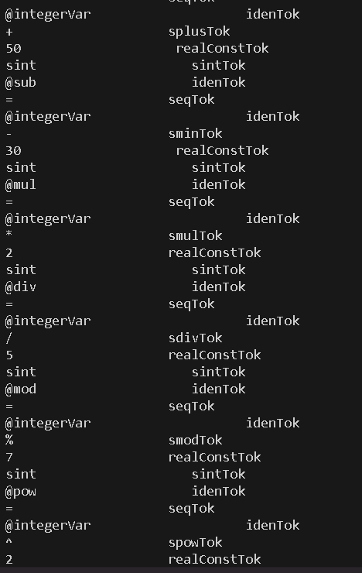
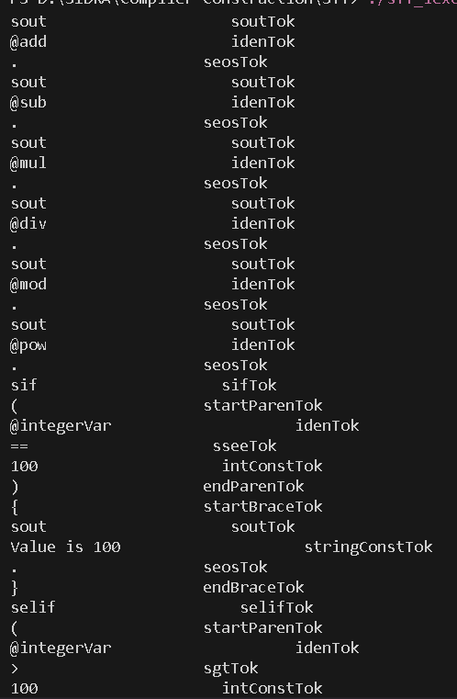
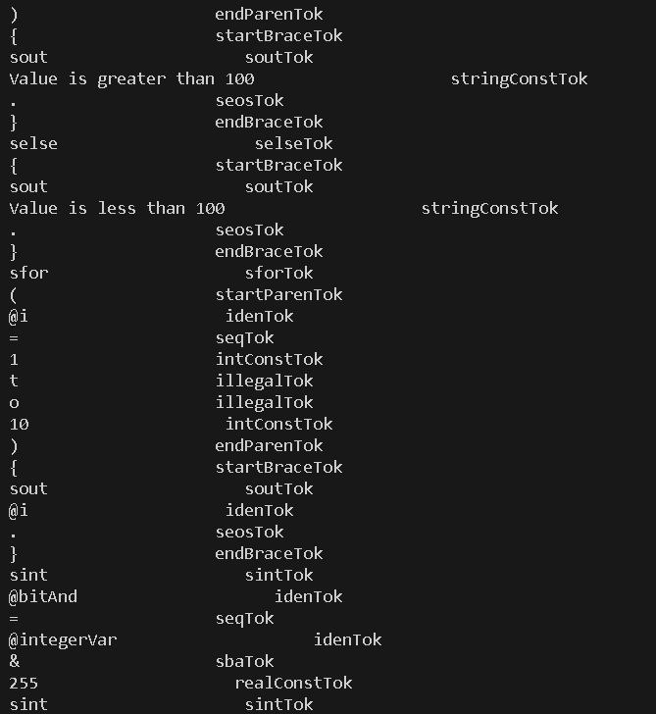
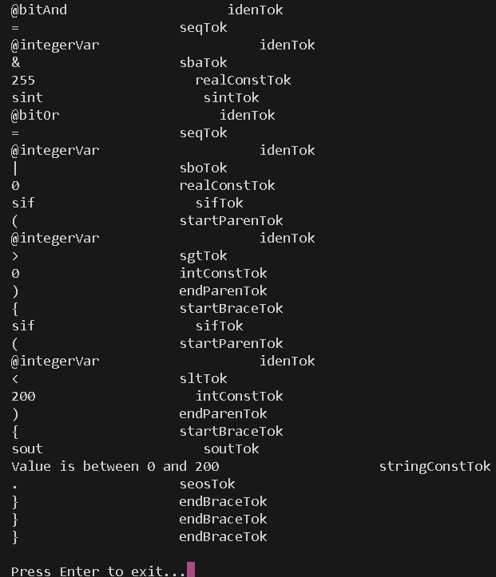

“THE END”

